NAME: SHEHU HUSSEIN AMEER
MATRIC NUMBER: 19/MHS01/397
DEPARTMENT: MEDICINE AND SURGERY
COURSE CODE: BIO 102
GENERAL BIOLOGY II (SECOND ONLINE ASSIGNMENT)
- How are fungi important to mankind?
Answer
Humans use fungi for many purposes. Some include:
- Fungi are responsible for the mediation of decay of organic matter. Without fungi and other microbes, the surface of the earth would have been clogged up with dead matters with all the various elements locked up in them.
- Yeast [an example of fungi] are important in food industry. Mushrooms are eaten by many human societies. Species like Penicillum notatum produce important antibiotics.
- Some fungi are parasites to some certain offensive pests e.g. houseflies, grasshoppers and therefore constitute important biological control agents in regard to such pests.
- They mediate the spoilage of wood, food, clothes and paper. Many are plants pathogens causing blights and smuts in cereals (Helminthosporium maydis and Ustilago zeac respiration).
- Illustrate the cell structure of a unicellular fungus with a well labeled diagram.
Answer
A best known unicellular fungus is Bread yeast, Saccharomyces cerevisiae, (Bakers’ yeast). It causes bread to rise by releasing CO2 which gets trapped in the dough. The cell structure is very simple, though the organism is one of the more advanced fungal forms from the point of view of its spore-producing structures. Yeast cells are found on exposed surgary fluids e.g. palm wine and surgary fruits where fermentation processes are mediated. It exists in diploid/haploid states. Under favourable condition, in both states, they multiply rapidly by simple mitotic cell divisions. Budding in yeast involves nuclear division and division of the cytoplasm in such a way that one segment of the constricted cytoplasm is smaller than the others. Diploid cells arise from haploid cells by processes of plasmogamy and karyogamy. A diploid cell may undergo meiosis under certain conditions to produce 4 haploid spores, acospores (contained in simple structure- an ascus).
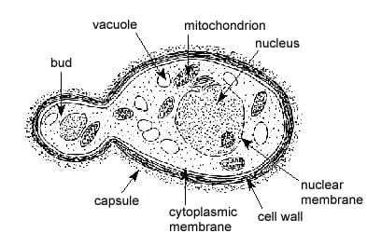
The structure of Saccharomcyes cerevisiae (Yeast) undergoimg asexual reproduction{budding}.
- Outline the sexual reproduction in a typical filamentous form of fungi.
Answer
The fundamental form in which most fungi exist is the filamentous form. Rhizopus stolonifer is a typical example. Rhizopus stolonifer is a filamentous and coenocytic species found growing on wet bread, fruits or other exposed food materials. Sexual reproduction in rhizopus occurs when two mating types of hyphae(rhizopus) grow in the same medium. Chemical interaction in the two mating types of hyphae produces growths perpendicular to the hyphae in opposite directions. These growths are delimited by a wall such that many nuclei are isolated in what is called a gametangium. The two gametangia fuse(plasmogamy) and a zygote is formed which may undergo prolonged dormancy or resting stage. The nuclei in the zygote fuse in twos and undergo meiosis independently. The zygote germinates under favourable condition to produce a fruiting which at maturity liberates the haploid spores.
- How do bryophytes adapt to their environment?
Answer
- They have definite structures for water and nutrient absorption from the soil; therefore, the plant body is divided into two {an aerial portion and a subterranean portion}. The subterranean portion is the rhizoid and is not a true root of the case of land plants that are advanced.
- The aerial portion being exposed to the atmosphere demands some modifications that prevents excessive loss of water through the body surface (i.e. dessication).
- They have other modifications that permit elimination of excess water from the plant body and not only exchange of gases between the internal parts of the plant and the atmosphere therefore openings are available on the aerial parts of the plant.
- Describle with illustration the following terminologies: (a)eusteles (b)atactostele (c)siphonostele (d)dictyostele.
Answer
- Eusteles: This is a type of siphonostele, in which the vascular tissue in the stem forms central ring of bundles around a pith. They are usually found in herbaceous dicotyledonous plants. The vascular bundles are discrete, concentric collateral bundles of xylem and phloem. There are a few sub-types of eusteles, including equisetum stele and atactostele.
- Atactostele: This is a type of eustele that is found in grasses and many monocotyledonous plants in which the vascular bundles are scattered.
- Siphonostele: Siphonostele is a cylindrical stele enclosing a parencymatous pith, usually found in more advanced vascular systems and higher vascular plants. They are found in stems of most monilophytes, especially the leptosporangiate or true ferns. There are few sub-types of siphonosteles, including dictyosteles, polycyclic dictyosteles, and solenosteles.
- Dictyostele: In siphonosteles, vascular supply to leaves is associated with leaf gaps and the conducting cylinder is a dissected one known as dictyostele. It has a single ring of xylem which is broken up by several leaf gaps. Phloem surrounds this xylem ring.
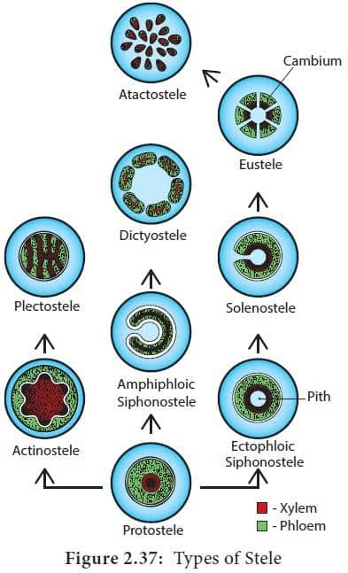
6.illustrate the life cycle of a primitive vascular plant.
Answer
A typical example of a very primitive vascular plant is Psilotum. The plant body has horizontal and vertical axes; not differentiated into stems and roots.the stem’s anatomy is root like and protostelic having a large cortex. The vertical axes are photosynthetic having stomata. Leaf-life appendages on the vertical axes of the plant body are not true leaves because they lack vascular supply from stele. Branching is dichotomous as in other primitive forms. Species of psilotum are small plants (up to 33cm tall) found in moist, humid soils in warm environments. The sporophyte is the dominant generation among among plants. Three-lobed sporangia (each suspended by two scales) are borne on the vertical axes. The sporangium contains haploid spores and originates from diploid cells of the stem. Sporangium develops into a globose structure inside which sporogenous cells undergo meiosis to produce haploid spores. Short stalk of the sporangium has a trace connected to the stele of the vertical axis. The plant is homosporous i.e. spores have uniform size and shape. Spores after liberation geminate into cylindrical, dichotomously-branched gametophytes. Gametophytes are saprophytic, and often associated with certain filamentous fungi in mycorrhizal relationship and are hardly visible to the naked eyes. Externally, they have many rhizoids and internally, they are largle parenchymatous. At maturity, the terminal ends of the cylindrical branches bear the archegonia while the antheridia are borne as protuberances lower down the branches. Sperms having flagella are released when antheridia are ripe which swim into the archegonia and the resulting zygote subsequently develops into a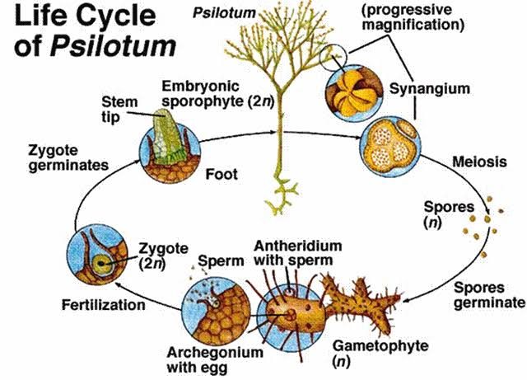 sporophyte.

